Mechanical Overview

Year: 2025 Semester: Spring Team: 15 Project: αCassiopeiae 8800

Creation Date: February 15, 2025 Last Modified: February 15, 2025

Author: Brian Lu Email: [lu964@purdue.edu](mailto:lu964@purdue.edu)

Assignment Evaluation: See Rubric on Brightspace Assignment

* 1. Commercial Product Packaging

To guide the design of the mechanical packaging for the αCassiopeiae 8800, two primary products were analyzed for their commercial relevance:

* 1. Product #1: Altair 8800

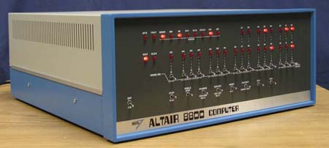

The original Altair 8800 is a large, boxy enclosure with a front panel of toggle switches and LEDs [1]. Its distinct rectangular aluminum casing and modular card-based architecture offer inspiration for maintaining the retro aesthetic. However, the large size and outdated internal layout will be modernized for portability and efficiency. The αCassiopeiae 8800 will retain the iconic front panel but shrink the overall dimensions to approximately 1/3 of the original size using modern fabrication techniques.

* 1. Product #2: Altair 8800 Mini

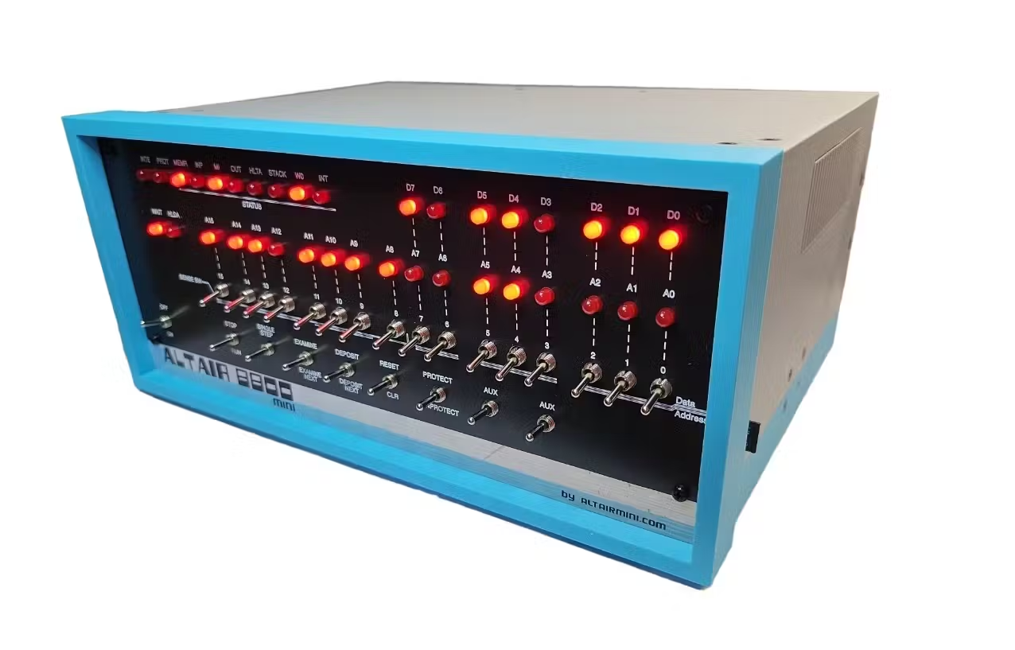

The Altair 8800 Mini offers a simplified and smaller version of the Altair, but sacrifices the modularity of the original backplane and cards [2]. The αCassiopeiae 8800 will improve upon this by incorporating modular expansion cards and a fully functional backplane, all while maintaining a compact form factor. Additionally, modern connectors (e.g., DDR4-style edge connectors) will be used for improved signal integrity and ease of use.

2.0 Project Packaging Description

The αCassiopeiae 8800 will be housed in a two-part aluminum extrusion enclosure. This design choice is informed by its durability, ease of assembly, and ability to emulate the original Altair’s aesthetic. The enclosure consists of:

3.0 Sources Cited

[1] “Daves old computers - altair 8800,” DAVES OLD COMPUTERS- ALTAIR 8800, <http://dunfield.classiccmp.org/altair/index.htm> (accessed Feb. 15, 2025).

[2] “Altair 8800 mini new version WIFI + internal terminal,” Altair 8800 Mini, <https://altairmini.com/store/product/altair-8800-mini-new-version-wifi-internal-terminal> (accessed Feb. 15, 2025).

Appendix 1: CAD Model Illustrations

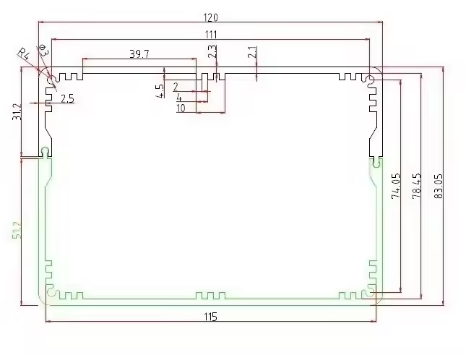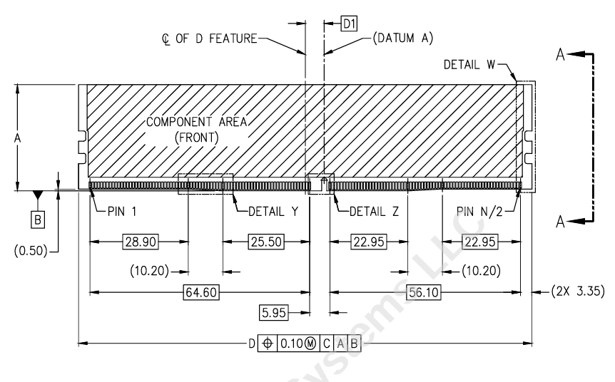

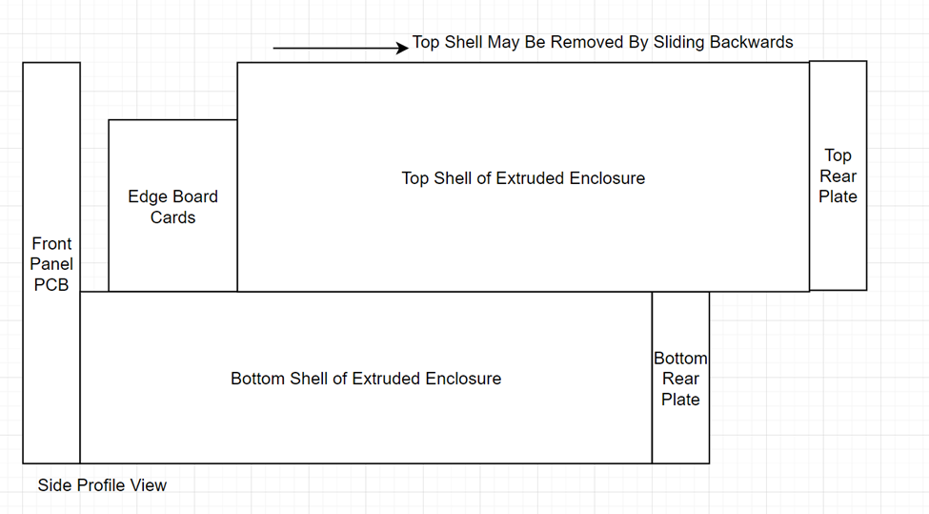Appendix 2: Project Packaging Specifications

|  |  |  |  |  |
| --- | --- | --- | --- | --- |
| *Material* | *Tooling* | *Quantity* | *Weight (g)* | *Cost ($)* |
| *Aluminum Enclosure* | *Extrusion* | *1* | *500* | *50.00* |
| *3D-printed rear panel, legs* | *3D Printer* | *4 feet, 2 parts for the rear panel* | *80* | *5.00* |
| *Screws* | *Screwdriver* | *8 (4 front, 4 rear)* | *4.04* | *2.08* |
| *PCBs (Backplane, 2 Cards, Front Panel)* | *PCB Manufacturing Service* | *4* | *150* | *60.00* |

Appendix 3: PCB Footprint Layout

